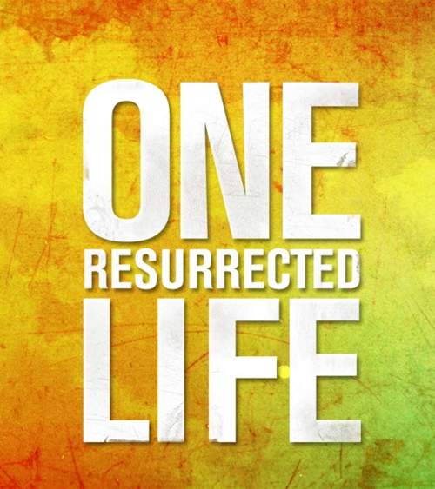
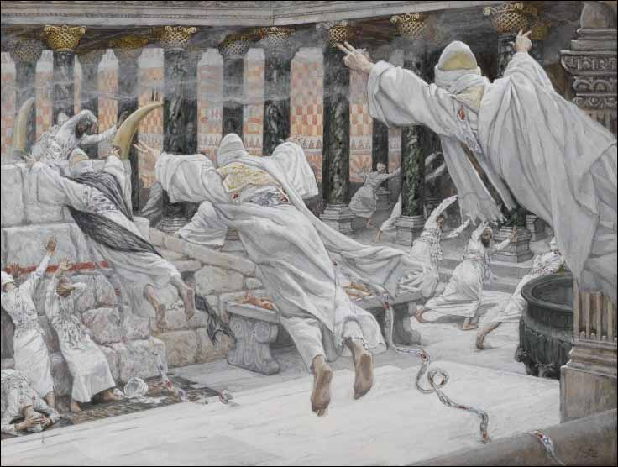

The Dead Appear in the Temple James
Tissot Matthew 27:52-53
Week #8
ONE RESURRECTED LIFE: Vindication

Discussion Starter: Share something about your Easter – where did you go, what did you do, what were the highlights?
What were some of the most meaningful lessons and experiences for you during the One Hell of a Day Lent season this year?

OPTIONAL: FOR THE LEADER – We have used a lot of James Tissot’s art during the Devotional readings through the Lent season. Tissot took three study trips to Israel to study the life, death and resurrection of Christ and then painted his reflections on the stories in the Gospels. If you are going to use this question you will have to make the picture (above) available to your group through pulling it up on the internet. (http://www.joyfulheart.com/holy-week/dead_appear_in_the_temple.htm)
Read Matthew 27:52-53 Why do you think that Christ’s death launched the resurrection of some of the dead from the tombs around Jerusalem? Do you think that Tissot’s vision of what that would have been like? What impact would the combination of seeing Jesus die and seeing your dead relative alive have on you?

STUDY
READ John 20:11-18
Earlier in the series we discovered that Mary Magdalene had been healed by Jesus from several demons. She had experienced a massive transformation of life through Him so now she didn’t know how to handle His death. What feelings and thoughts do you think Mary would have had with Jesus’ death? What feelings and thoughts would Mary have when she came up to the tomb only to find that Jesus’ body was not there?
Mary must have been confused and in a fog when she walked into the tomb only to find two angels sitting where Jesus should have been laying. Lest you think that was a normal thing in those days, it would not have been.
John next describes Mary’s meeting with Jesus. She didn’t recognize Him (of course not, she had dismissed Him as dead)! What did Mary’s

question in 20:15 indicate what she thought had happened to Jesus’ body?
When Jesus called her name and she immediately recognized Him, what does that indicate about her relationship with Christ?
What did she do next? (20:17)
The meaning of 20:17 is likely that Mary would have opportunity to see Jesus again, so she does not need to cling to him. Jesus could also be reminding Mary that after his crucifixion she cannot have him with her except through the Holy Spirit (see 16:5-16)
To hear Christ speak your name in a real and personal way takes an on-going relationship. Jesus taught that having the Holy Spirit would be better for us than having Christ in bodily form. How can you meet Christ now that He has been resurrected? Through His word, prayer, worship with other believers, living out God’s word in your week.

The rest of John 20-21 tells about Jesus’ appearances to His disciples and their reluctance to believe (disciples in the Upper Room and to Thomas. John 21 tells about Jesus appearing to four of the disciples by the shore of Galilee and dealing with their shame at their betrayal and abandonment of Christ at His arrest.
READ John 20:30-31 Based on the issues of the disciples (sorrow, doubt & shame), what are some of the issues that cause believers to struggle with believing and following Christ today, even though we can be certain in Christ’s love (His suffering and death on the cross for us) and His power (resurrection)?

All-Campus Reminders
A BIG Thanks! to all the groups who participated in the Easter Egg Hunt through service. The Lockwood Campus served hundreds of the community families and we had many come to me (Tim Weidlich) and the volunteers to say thanks for our service to the community. Great reflection of God’s love to our city!

