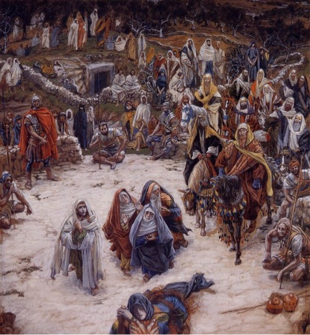

Week #7
The Price Christ Paid on the Cross

Discussion Starter: Nelson Mandella, in the movie “Invictus,” tells about Mendella’s 28 years of hard labor in prison under the white Apartheid regime. He was released under international pressure and as the white-run government gave more freedom to the black tribes they gained the freedom to vote. As a result Mandela won an easy majority in the election and became President of South Africa.
Rather than seeking revenge on those who had tortured and abused him, Mandella included whites in his new government. Invictus is the story of Mandella rallying the country around the Rugby team that was hated by the blacks during Apartheid. Rather than seeking revenge Mandella pulled the country together by forgiving those who had abused him and forgave.
If you had been under an oppressive apartheid government all of your life, and had been a political prisoner for nearly 30 years, what would you do with your newly acquired power as President of the country?

READ John 19:23-37
There are different groups standing around the cross with many reasons for being there. Jesus didn’t change the lives of everyone there, His death provided for that transformation, but they had to accept His work for them. We are going to consider each group and their attitude toward Christ and how it affected them.

SOLDIERS – 19:23-24 What benefit did the soldiers gain from Christ?
How could the soldiers have such an indifferent attitude toward Christ? To them, Christ was just another prisoner and trouble-maker. These prisoners were also the source of extra income by taking their clothing for themselves or selling them. Tomorrow they would take another prisoner, and another, and another. They had become indifferent toward prisoners and were looking for a Messiah!

Prisoners - Luke 23:32-33, 39-43 What was the difference between the two prisoners’ and their attitude toward Christ?
While tradition tells us that 2 other prisoners hung with Jesus that is mostly due to the conversation between two of them. It is likely that Jesus was crucified in the midst of several prisoners. Mark 15 indicates that they all hurled insults on Christ, but one was moved by the attitude and actions of Christ and was moved to repentance and conversion.
FAMILY – John 19:35-37 Jesus’ mother’s sister was probably the disciple John’s mother (Salome).
Luke 8:2-4 The twelve were with Him and also some women who had been cured of evil spirits and diseases: Mary (called Magdalene) from whom seven demons had come out; Joanna the wife of Chuza, the manager of Herod's household; Susanna; and many others. These women were helping to support them out of their own means.
What do you know of this group standing at the foot of the cross?
Why do you think that none of the Gospels mention the other disciples at the cross?

RELIGIOUS LEADERS - Matthew 27:38-44
Matthew begins his Gospels pointing out that the first to come worship Christ were shepherds and foreign Magi (Matthew 2). Here he finishes his Gospel showing the religious leaders who directed the Magi to the birthplace of Jesus following Christ to the cross to continue insulting Him.
Why do you think the religious leaders where so cruel and had such animosity toward Christ?

ALL THE PEOPLE
Luke 23:35-39
The people stood watching, and the rulers even sneered at him. They said, "He saved others; let him save himself if he is God's Messiah, the Chosen One." The soldiers also came up and mocked him. They offered him wine vinegar and said, "If you are the king of the Jews, save yourself." There was a written notice above him, which read: this is the king of the Jews. One of the criminals who hung there hurled insults at him: "Aren't you the Messiah? Save yourself and us!"
What was the common condemnation of each group on Jesus? If you are the king of the Jews, save yourself. Therefore, they could not fathom that He would stay on the cross if He could take Himself off.
If Christ could have come down and didn’t, why did He take the punishment and abuse?

CHRIST’S RESPONSE
LUKE 23:32-34
Two other men, both criminals, were also led out with him to be executed. When they came to the place called the Skull, they crucified him there, along with the criminals—one on his right, the other on his left. Jesus said, "Father, forgive them, for they do not know what they are doing." And they divided up his clothes by casting lots.
What do these character studies reveal about the need for Christ to come invade our world to save us? Would we have pursued God if He didn’t come to us?

RESPONSE OF SOME TO CHRIST’S UNCONDITIONAL LOVE
Luke 23:47-49 The centurion, seeing what had happened, praised God and said, "Surely this was a righteous man." When all the people who had gathered to witness this sight saw what took place, they beat their breasts and went away. But all those who knew him, including the women who had followed him from Galilee, stood at a distance, watching these things.
Who are the groups Luke mentions and what is their response to Christ’s unconditional love?
What does this say about why you did respond in repentance to Christ’s love?
What should you expect from most people in their response to Christ’s love based on this study?

Spend some time praying for those in your group’s influence who might be moved toward Christ this coming Easter weekend.

All-Campus Reminders
This coming weekend is our Good Friday service when you will have a chance to worship through the biblical stations of the cross. This would be a great Small Group event followed by a de-brief at an Ice Cream or Coffee Shop.
This weekend’s Easter Egg Hunt and Easter services are great opportunities to invite friends.

