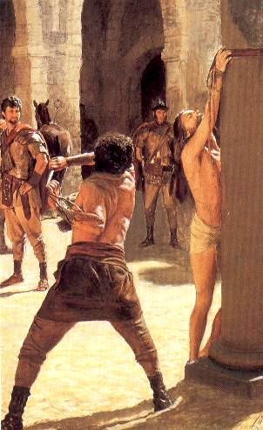

Week #6
A World at War with God

READ Matthew 27:26-32
Discussion Starter: Matthew presents four groups in this segment of Jesus’ walk to the cross.
- Jews - who push Pilate to crucify Jesus even though Pilate finds Him not guilty. Of these are religious leaders who want Christ out of their lives because He threatens their authority and position, and the crowds who are presented as manipulated but willing participants.
- Pilate, a political pawn caught between the Roman government and the Jews. He is pressured from Rome, Jewish leaders and his wife. He is afraid to pronounce Jesus guilty because he believes he is innocent, his wife warns him of his innocence, but the crowd threatens his job so he flogs Jesus and releases him to the Jews for crucifixion.
- 300-600 soldiers of the Governor (Pilate) who were recruited from the non-Jews living in Israel. They seem to be hostile toward Christ and venting their hatred of the Jews.
- Simon from Cyrene (Libya) who was caught in the crowd and forced to carry the cross beam of Jesus to Golgotha. He is passive in his response to Jesus, he didn’t stand up for Him or offer to carry His cross, but was forced into service by the roman soldiers.
Identify how each group responds to Jesus during His trial. This will take some review of the text and is an advanced level question so be ready with guiding the group through it.
As you consider these groups, which group or person do you identify most with and why?
The harsh reality is that every one of the individuals and groups expose me at several points in my life. Even Jesus’ disciples abandoned Christ; he suffered and died alone. The point of the story is that if I were a part of any of the groups in Jerusalem during this story, I would fit into one of the groups that tortured Jesus or abandoned Him.

WATCH - Optional - Adam Hamilton DVD “24 Hours That Changed the World” Session #5 (about 9 minutes)

The torture of Jesus reveals the dark side of humanity’s response to God. There is no group that comes to Jesus’ defense, and those who might (the disciples) have abandoned Christ for fear of their lives (Romans 3:9-18)
The Gospels all describe the persecutions of Christ in some detail. What does Isaiah 53:4-5 say is the purpose of Christ taking this brutal beating?
READ Isaiah 53:4–5 “Yet it was our weaknesses he carried; it was our sorrows that weighed him down. And we thought his troubles were a punishment from God, a punishment for his own sins! But he was pierced for our rebellion, crushed for our sins. He was beaten so we could be whole. He was whipped so we could be healed.”
While your failures still hurt and destroy yourself and others, Christ carried the guilt of your failures for you. Therefore, when you recognize your failure and turn away, you don’t have to pay for that failure, but in turning you are forgiven and free.
As a child I was taught in the way I was punished that sin had to be paid for through my punishment and a period of grief and suffering the consequences. While sin has its consequences, Isaiah tells us that the guilt of those failures was carried by Christ in His torture.

READ: 1st John 1:8-10
Confess our sins – from a Greek word meaning “to say the same thing” or “agree.” It means coming to terms with an issue in our lives and seeing God’s view of it and acknowledging the damage done by it to ourselves and to others.
Faithful and just to forgive our sins – This combination means that God will apply His justice served in Christ’s torture and death to our account every time we acknowledge our sins.
According to these verses, how does a Christ follower respond to sin in his/her life once it has been exposed?
Do you have to do any penance for your sin? Once your failure has been exposed and you acknowledge it, you are freed from its guilt, shame and punishment.
If Christ paid the penalty for your sin, how should I view my failure once I have acknowledged it to God or to another? I should forgive myself and replace that failure with Christ’s forgiveness and character.

How should I respond to another who has failed me?
READ: Matthew 6:12 “and forgive us our sins, as we have forgiven those who sin against us.”
Matthew 6:14–15 “If you forgive those who sin against you, your heavenly Father will forgive you. But if you refuse to forgive others, your Father will not forgive your sins.”
We often respond to another’s hurt by trying to make them feel the pain we think they have caused us, so we cut them off or talk about them to others…. Forgiveness doesn’t mean we allow them to treat us poorly, but when they acknowledge their failure, we apply Christ’s payment for our sin to their account as well.

Give an illustration of a relationship where you need to apply Christ’s forgiveness this week.

Discuss how each person’s Lent fast is going. Is your fast helping you appreciate Christ’s suffering for you? Is your fast helping you spend more time with Christ?
Take time to discuss your Small Group’s Service Project coming up. Joe is asking all Small Groups to sign up to help with filling Easter Eggs and perhaps to help with the Easter Egg hunts coming up. Details at http://www.onehellofaday.com/almsgiving-through-a-small-group

