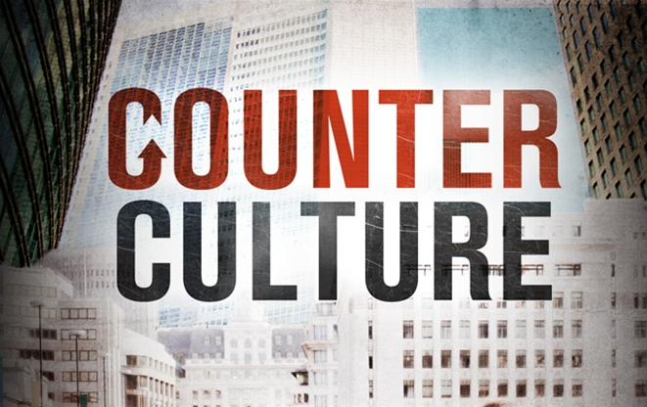
PART III Redemption
October 22-23, 2011
Discussion Starter:
We have been talking about developing a biblical world-view.
A world-view is your perspective on how life works and why things work the way that they do.
In the Counter Culture series we have worked on our biblical world view by understanding God’s plan for Creation (here by design), people’s condition before God and each other because of the Fall (we turned from our Creator and his design).
A biblical world-view conflicts with most people’s view of the world. Our society believes that we are here by chance (by accident) instead of by Design. We are all basically good instead of the biblical view of a core that is broken and separated from God. We make life better by doing good things instead of accepting God’s re-creation and following His leadership.
Start your discussion by giving illustrations of how you see those three ideas (World View) in the people in your neighborhood, work, friends, family, government, world.
We are here by chance – therefore live for yourself
We are basically good – therefore what God calls sin is actually a personal preference
We should do good things –

The Beginning of a Biblical World View
READ Romans 8:20-23
The Bible tells us that we live in a world populated by people who are sinful at their core. Sin as an attempt to make life work without God and His authority. Sins are the expressions of rebellion.
How does creation display a brokenness (the Bible calls it “groaning) that needs repair? These would include natural disasters, or even issues were fallen people destroy nature. Genesis 3 talks about the curse of creation being thorns and a kind of battle now between people and creation.
Many theologians describe the basic issue that demonstrates our brokenness is relational. In other words, the primary demonstration that our lives are broken and need repair.
Vern talked about abortion as a result of a world-view that believes that we are here by chance. How does our society, or families, and people display a brokenness that needs repair. E.g. politics, family, culture, art, technology. Many ways that God’s original design for creation and relationships are falling apart.

If your group is interested in investigating the biblical teaching on the source of sin you can use this next section, otherwise move on to the next section.
Sinful Nature
READ Romans 5:12-15, 18-19
What bothers you about the idea that we are guilty for Adam’s choice?
How do you think the American idea of independent, self-determined approach to life might affect of guilt by community? If sin results in broken community, then Adam’s sin passed down a propensity to destroy relationships.
READ Psalm 51:5-6
This passage talks about being born with a predisposition to rebellion. What evidences do you see that everyone is born with a sinful nature?
If we are born in sin, why aren’t we worse than we are? The Bible talks about constraints to sin such as civil laws, families, social norms, human conscience, healthy fear that keep us from going fully into our sinful nature. 1st Thessalonians also talks about all those restraints being removed before the end.

While we are not completely evil, because we all have God’s image and likeness created in us, we were bent toward habits that destroyed relationships. This propensity needs to be reconciled.
READ 2nd Corinthians 5:17-20
To reconcile means: the exchange of hostility for a friendly relationship.
What was the price Christ paid to buy us back to a relationship with Him? (5:21 the original text says in place of to be the offering for our sin to actually to become sin itself.
How did Christ call you to reconciliation with Him? God uses people to connect with you to show you and tell you about God’s offer for a relationship with Him.
To call others to a relationship with God assumes renewed relationships with people.
READ Ephesians 2:16-18
Besides reconciling people to God, what does this passage say that the Gospel also reconciles? The Gospel reconciled two hostile groups: Jews & Gentiles.
How can the Church reflect God’s desire for reconciliation of hostile groups in our culture today? e.g. racial discrimination, those with wealth with those in poverty, Native American with whites, community in conflicts (Heights with “lower Billings”), divorced, broken families….
Matthew 5:24 tells us to reconcile before we worship and 1st Corinthians 11:20-34 tells us to reconcile conflict and divisions before the Church celebrates the Lord’s Supper. How can Harvest and your Small Group do better at reflecting conflict resolution?
READ Colossians 1:20
Romans 8:20-22 says that all creation groans to be reconciled to its former state before the fall. How do Christians bring reconciliation to God’s design of creation?

BIG IDEA: God’s work of Regeneration begins with a person’s reconciliation with God through Christ’s payment for my guilt. But reconciliation, and the Church’s call to become reconcilers, only begins at a person’s new birth! We are called to reconcile divisions in relationships, in communities and even between people and creation.

What can you or your Small Group do to be reconcilers this week?

William Arndt, Frederick W. Danker and Walter Bauer, A Greek-English Lexicon of the New Testament and Other Early Christian Literature, 3rd ed., 521 (Chicago: University of Chicago Press, 2000).

