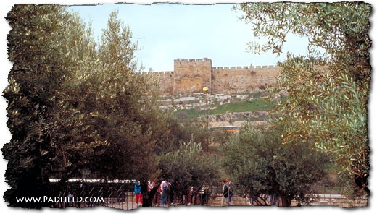

Week #3
Gethsemane – How Jesus Prepared for Suffering

Discussion Starter: Before going up to the Mount of Olives, Jesus and his disciples sang a hymn (Mark 14:26), probably several of what are called the “Hallel psalms.” Psalm 113-114 were sung before the Passover meal, and Psalms 115-118 were sung afterward.
Last week we said that there is no way for us to know the events coming in our future, but God does and prepares us to face them if we will listen. Jesus warned the disciples in the Upper Room that they would all run from him, he told Peter of his betrayal as well. However they couldn’t imagine a situation where that could come true, so they didn’t feel a need to pray.
Read Psalm 118, one of the songs the group would have sung before going to the Garden. Discuss how this chapter would help Jesus as He prepared for the suffering He knew was coming that night.

Adam Hamilton DVD “24 Hours That Changed the World” Session #2 (about 7 minutes)
You’ve read the Psalm the disciples would have sung as they left to go to the Garden of Gethsemane, you’ve seen the area of the Garden. Here Jesus struggled with His Father over the suffering to come. Now read about the events and Jesus’ suffering in the Garden.
READ Mark 14:27-42
All friendships fail one another eventually. We either fall short of our friend’s expectations or just fail to stand with them in their need. This passage is both about standing with a friend when they need us, and learning to rely on God when no one else can really understand the burden we are bearing. Jesus warned the disciples that they would ALL desert Him that night. When Peter told Jesus that He was wrong Jesus told Peter that he would deny that he had ever known Jesus three times that night!
If you are Peter, and Jesus just told you that you would deny Him, how would you feel, or what would you do? Try to avoid the easy answer in hind-sight that they would pray. Peter’s pride kept him from admitting that he had faults or accepting Jesus’ warnings as a call for action on his part. Peter should have first asked Christ why he would betray Him, and take His warning to pray for strength to face the temptation.
From verses 33-34 what indications does Mark give of the extent of Jesus’ struggle? “deeply grieved” means “in deep anguish or pain.” Jesus says

“even to the point of death. When He went to pray it says that “He fell to the ground”, or even “threw Himself to the ground.”
Have you had a friend go through a time of deep pain when you wanted to do something for them but didn’t know where to start? When someone goes into the hospital, do you visit them or leave them alone? When a friend has a child get in trouble with the law, do you say something and fear embarrassing them?
What do you think Jesus meant when He asked Peter, James and John to keep watch? (14:34, 37-38) The word is used “to stay awake” or “be alert.” This is a different word than prayer, although Jesus adds prayer to it in vs. 38. Perhaps to keep his back for a look-out for the soldiers or perhaps to pray with Him.
Read Jesus’ prayer in 14:35-36 again. What emotions or desires does Jesus express in His prayers? Grief, fear, self-preservation & trust.
Vern explained that the “cup” Jesus asked to be removed meant judgment that God gave for disobedience to His Law. How does Jesus’ prayer inform or affect your understanding of who Jesus is? This question directs people toward the exposure of Jesus’ humanity. He had all the emotions that we have and expressed them in a healthy way. Yet many Christians feel guilty for admitting their true emotions to God. That is the essence of prayer

Have you ever struggled with something that you felt God wanted you to do, but you did not want to do it? How did you resolve that (if you did)?

Mark contrasts the disciples’ lack of reliance on God for the struggles to come with Jesus’ preparation through authentic and intense prayer. Which one do you identify with currently and what do you need to do to prepare yourself for whatever is coming for you.

Has your group considered taking the Harvest Bible Institute Biblical Leadership class starting Wednesday, March 30th from 6:30-8:00 at the Lockwood campus? Check out the Church website for details of the class.
http://www.harvestweb.net/heights_bibleinstitute

