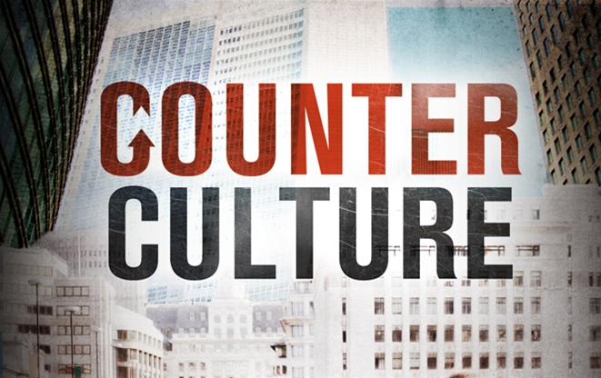
PART II Creation-Fall
Biblical Worldview (G. Barna)
- Absolute moral truth exists
- Bible is the source of that truth
- Jesus lived a sinless life
- God created the universe and continues to rule it
- Salvation is a gift from God
- Satan is a real living entity
- Christians have a personal obligation to share the Gospel.
- The Bible is accurate in all of its teaching.

October 8-9, 2011
Discussion Starter:
What does the German word, “weltanschauung” mean? It is the German word for World View. Don’t know why that’s important for you to know, but it makes you smarter!

Vern talked about the elements of a Christian World View. He wasn’t able to spend time talking about these elements. Discuss what you think every Christian ought to know? Do you agree with these basic elements?

The Beginning of a Biblical World View
Vern started the issue of a biblical worldview with a discussion of origins. Why does where we came from determine so much about our view of God’s existence? If we are here by chance (naturalism) then there is no God or purpose for life. If God designed the universe and controlled its formation than there is a purpose and design for us.

Who Are We?
READ: Genesis 1:26-28
What does it mean to be made in God’s image and likeness? God treats you with dignity and with capacity to create & manage the resources He created.

What lights you up when you do that activity? How does that reflect God’s creative nature?

Why Are We Here?
Vern talked about being made for a relationship with God, a relationship with others and a relationship with the earth.

How do you see these three relationships broken in your sphere of relationships? People generally don’t live with God in their lifestyle, Friendships and marriages don’t last, people destroy our environment for the sake of comfort and profit & the Church is not much different than the secular world.

READ Genesis 3:20-21
Adam names his wife “Eve” meaning “the bringer of life.” Meaning Adam believed that God’s hope would come through Eve’s off-spring some day.
God killed some animals to cover Adam & Eve’s nakedness, their sin. This was a picture of the blood had to be shed to cover our sin.
Vern ended with four ways our sin (independence from our Designer) disrupts His plan for us. Discuss how you have experienced one of these disruptions:
1) Disrupts our relationship with God – Not just as unbelievers, how does our independence carry over and disrupt God’s plan for us?
2) Disrupts our relationship with ourselves – How is our perspective of ourselves disrupted when we don’t have God’s view of our identity?
3) Disrupts our relationship with each other – How does our independence and fear distort our relationships?
4) Disrupts our relationship with creation – How are we destroying God’s creation rather than protecting it, enjoying it, developing it?

What questions do you have about our origins in what the Bible tells us about God’s design and Evolutionary Biology? Group Leaders – keep this discussion from the young earth vs. evolution time-line and keep it on God’s creative design verses chance.

Finalize your Group’s plans for your Compassion Weekend project

Compassion Weekend – October 15-16

