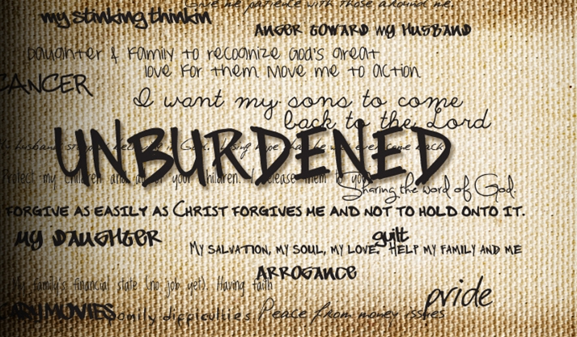
PART V Affair-Proof Your Marriage
December 3-4, 2011

Group Leader: While many marriages are struggling with their relationship, many are anywhere from ambivalent to celebrative. It would be awkward to discuss marriage commitment if one of your group is in the middle of turmoil. The focus of this discussion guide will focus on God’s intent and attitude toward marriage rather than the wrong attitude in marriage. This week may be a time for you as the Small Group Leader to shepherd your struggling couples. If someone is in the middle of marriage conflict they will likely be withdrawing from your group. Give them a call and encourage them to contact Eric Hutch for some help.
Getting Started
Vern described the Romantic stage of dating and early marriage, then the kids stage. Some have been married through several stages of a married relationship. Describe the stages of marriage as you look back on your married life.

The Marriage Design:
READ: Genesis 2:18-25
A Garden to Work - In 8-15 Moses describes the working environment in the Garden. What was the Garden like? Be descriptive….note the details. What did he put Adam in the Garden for Adam to work with?
There aren’t many limitations in the Garden, but Moses sites 1 in verses 16-17, what is that limitation?
The prohibition from eating from 1 tree in the Garden is given in the context of defining love and the marriage relationship. Love must involve a choice, if there is no choice, it isn’t love. If there isn’t a way out, there is no potential for growth. So, while we usually look at the tree of knowledge of good and evil as a negative thing, it really is very positive, there has to be a choice in love. That choice is in all of marriage, you can never presume on your spouse’s love and courting them. Every marriage has a tree of the knowledge of good and evil.

There are many choices that will take you away from love, what are some examples of choices that move you from loving your spouse?

More Than A Great Job - 2:18 After describing Adam’s pristine work conditions, what s the next issue God addresses? While work may be satisfying, it apparently isn’t enough. However, Adam doesn’t realize that he’s missing something, he’s never known anything else. So God give Adam a project to discover what’s missing in his “perfect world.”
2:19-20 What did God give Adam to do?
2:20 What was Adam’s conclusion after he finished naming the animals?
What are some of the ways you discovered that you were incomplete and desired a spouse?
The naming of the animals, a scene which portrays man as monarch of all he surveys, poignantly reveals him as a social being, made for fellowship, not power: he will not live until he loves, giving himself away (24) to another on his own level. So the woman is presented wholly as his partner and counterpart; nothing is yet said of her as childbearer. She is valued for herself alone. Derek Kidner “Genesis: An Introduction and Commentary,” Tyndale
God’s Design for Marriage - 2:21-22 I had a girl reading the Bible for the first time ask why Eve was made from Adam’s side rather than made from the ground like Adam and the animals. How would you answer her?
This is the only full account of the creation of woman in ancient Near Eastern literature! The woman was made from Adam’s side in answer to God’s statement in 2:18 that she would be a helper “fit for him” (ESV) or “to complete him.” Eve makes up the differences Adam lacked just as Adam makes up the differences that Eve lacked.
Why do you think God created Adam single, when he made all the animals with a male and female? God started Adam as a single to experience his incompleteness and need.

GL - There are many lessons taught in this short paragraph. You may want to mention them as they might help your group. It is helpful to observe the content of Scripture.
In more detail, we may find the following emphases here. First, man is prior to woman (1 Cor. 11:8, 9; 1 Tim. 2:13). Secondly, the sexes are complementary: the true partnership is expounded by the terms that are used (a helper fit for him, 18, 20, RSV; literally ‘a help as opposite him’, i.e. ‘corresponding to him’), by the fruitless search elsewhere, such as putting himself into the work God gave him, as man discerns the natures of the animals (expressing them in the names, 20) of other creatures, and by the fact that Eve is of the very stuff of Adam and yet a wholly new being. Adam’s joyful ‘at last …’ (23, RSV) grows into the first poetic couplet in the Bible, and his work of naming is triumphantly concluded in a title that echoes his own. Thirdly, the union of the two in marriage is to be an exclusive (a man leaves …, 24, RSV), permanent (… and cleaves), God-sealed bond (one flesh: cf. Mark 10:8f.); for ‘God himself, like a father of the bride, leads the woman to the man’ (G. von Rad).²³ Fourthly, there is, in God’s true pattern, perfect ease between them (25). But it is the fruit of perfect love, which has no alloy of greed, distrust or dishonor; it was understandably an immediate casualty of the fall (see further on 3:7), and the chapter ends with a pointed reminder of our vanished concord.
Lessons on Marriage from Genesis 2
1) God allowed Adam to experience his need for completion.
2) However perfect our work environment, it won’t complete us without relationships.
3) While man and women are different, those differences are the components of completeness. Differences are necessary for completeness.
4) God celebrates marriage by designing a partner that is different and by ushering the bride to the groom. Notice that the first miracle Jesus performs is providing wine at a wedding in Cana (John 2)
5) “Naked and unashamed” indicates that the husband and wife had nothing to hide, but thrived in being exposed to each other without rejection. The first change after the fall was that the man and woman covered their bodies with fig leaves.

Which lesson from Genesis 2 is most helpful to you right now?

Recommendation: The key verse for an Affair-proof Marriage is Ephesians 5:31-33 “As the Scriptures say, “A man leaves his father and mother and is joined to his wife, and the two are united into one.” This is a great mystery, but it is an illustration of the way Christ and the church are one. So again I say, each man must love his wife as he loves himself, and the wife must respect her husband.” (NLT) Ask the group to memorize this verse and claim it with their choice to grant God’s forgiveness to the person or offense.

Check out the Unburdened website that will help you through this series at www.unburdened.me The Resources page has some extra help in the category of an Affair Proof Marriage.

Derek Kidner, vol. 1, Genesis: An Introduction and Commentary, Tyndale Old Testament Commentaries, 70-71 (Downers Grove, IL: InterVarsity Press, 1967).

